**DATAWEAVE TASK-2**

Use the following payload and retrieve the status from each object  
**Input Payload:**

{  
 "0": {  
 "payload": {  
 "status": "Running"  
 },  
 "attributes": {  
   
 }  
 },  
 "1": {  
 "payload": {  
 "status": "Not Running"  
 },  
 "attributes": {  
  
 }  
 }  
}

Output Payload:

["Running", "Not Running"]

**Solution:**

There are two ways to solve this transformation.  
One is using descendants operator. The descendants operator can be used when you need the values of a particular key in the payload irrespective of where they are in the payload.

Just giving payload..status will fetch us the expected output.

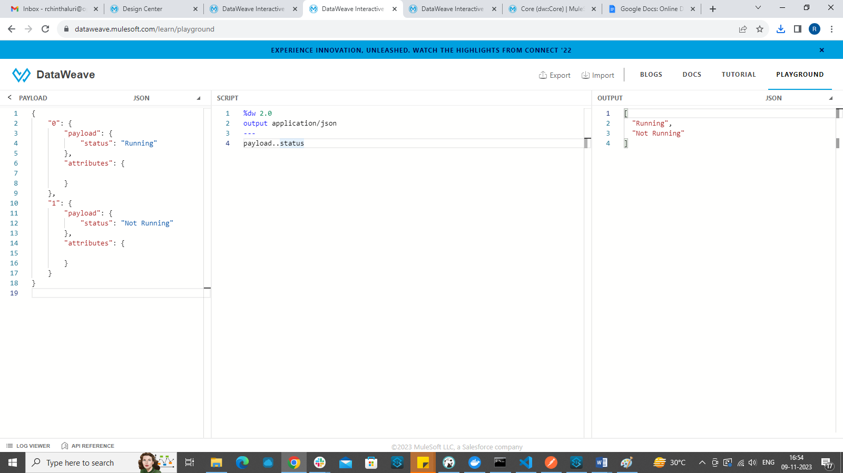

The second way is to use mapObject and pluck.

%dw 2.0

output application/json

---

(payload mapObject ((item,key, index ) -> item[0])) pluck $

